Concepts and Visual Representations
Association, composition and aggregation
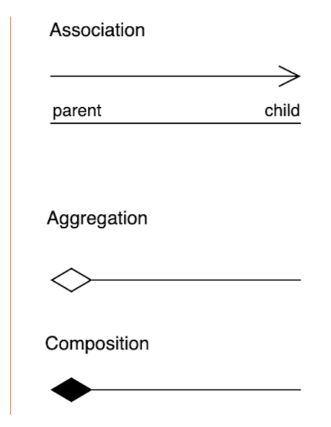
Association is a generic term that refers to the relationship between two independent classes. The relationship can be one-to-one, one-to-many, or many-to-many, but it does not necessarily imply ownership. In other words, an association simply indicates that two classes are related in some way, but the lifecycle of one class does not depend on the other.
Aggregation is a specific form of association in which one class, the whole, contains a collection of other classes, the parts; here, however, the lifecycle of the parts does not depend upon the whole. For example, a library and books show aggregation, since books may exist somewhere apart from the library.
In contrast, composition is a stronger form of aggregation that means ownership and lifecycle dependence; if the whole gets destroyed, then the parts no longer exist. For composition, a good example would be a house and its different rooms; a room cannot exist without a house.
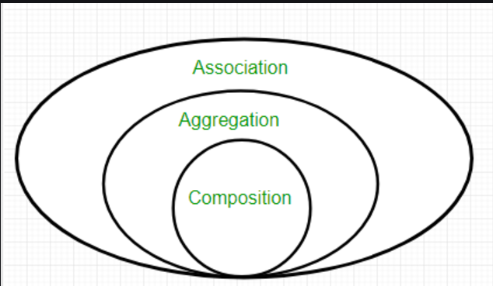
Association:
Relationship between two independent classes.
Association can be viewed as describing a “uses-a” relationship, where an object uses or interacts with another object in some way.

Unidirectional Association
This is an association where one class is aware of and associated with another class, but the reverse is not true. A Student class can be associated with a LibraryCard class, representing the relationship where a student has a library card.The LibraryCard class does not need to "know about" the Student class.

Bidirectional Association
This is an association where both classes are aware of each other and can interact with one another. A Teacher class and a Classroom class may be associated bidirectionally. A Teacher would know which Classroom they are assigned to, and the Classroom would know which Teacher is assigned to it.
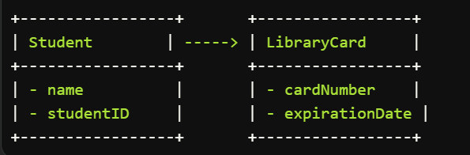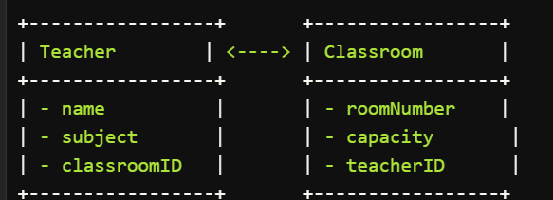
Aggregation:
Aggregation represents a "has-a" relationship between objects. One object (the "whole") contains or aggregates another object (the "part"). However, the part can exist independently of the whole.
Characteristics:
- The whole object has a reference to the part object.
- The part object can exist independently of the whole object.
- The lifecycle of the part object is not directly tied to the lifecycle of the whole object.
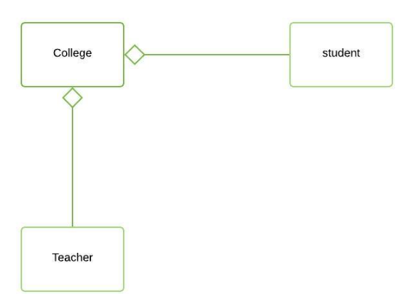
Code walkthrough:
This code demonstrates aggregation in C++ by creating a Department class that aggregates an array of Student objects.
#include <iostream>

using namespace std;

class Student {
private:
string name;
int id;

public:
Student(string name, int id) : name(name), id(id) {}

string getName() const { return name; }
int getId() const { return id; }
};

class Department {
private:
string name;
Student* students[3]; // Array of pointers to Student objects
int numStudents;

public:
Department(string name) : name(name), numStudents(0) {}

void addStudent(Student* student) {
if (numStudents < 3) {
students[numStudents++] = student;
} else {
cout << "Error: Department is full." << endl;
}
}

void printStudents() {
cout << "Students in " << name << ":" << endl;
for (int i = 0; i < numStudents; i++) {
cout << "- " << students[i]->getName() << " (ID: " << students[i]->getId() << ")" << endl;
}
}
};
Class Definitions:
- Student: Represents a student with a name and ID.
- Department: Represents a department with a name and an array of pointers to Student objects.

int main() {
Student alice("Alice", 12345);
Student bob("Bob", 67890);
Student charlie("Charlie", 98765);

Department cse("Computer Science");
cse.addStudent(&alice);
cse.addStudent(&bob);
cse.addStudent(&charlie);

cse.printStudents();

return 0;
}
• Creates three Student objects with names and IDs.
• Creates a Department object named "Computer Science".
• Adds the Student objects to the Department using the addStudent method.
• Prints the list of students in the department using the printStudents method
Aggregation Relationship:
- The Department class aggregates the Student objects through an array of pointers.
- The students array holds references to the Student objects, but it does not own them.
- The Student objects can exist independently of the Department object.
- The Department object manages the lifetime of the Student objects while they are associated with it.
Composition:
Composition represents a "part-of" relationship between objects. One object (the "whole") contains or composes another object (the "part"). The part cannot exist independently of the whole. When the whole object is destroyed, the part object is also destroyed.
Characteristics:
- The whole object has a reference to the part object.
- The part object cannot exist independently of the whole object.
- The lifecycle of the part object is directly tied to the lifecycle of the whole object.
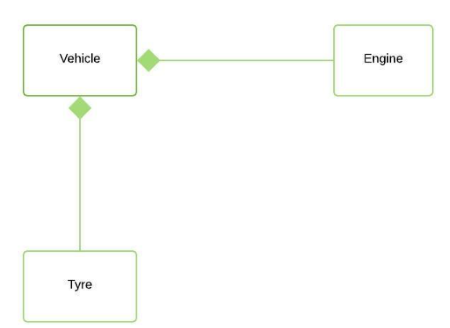
Code walkthrough:
class Engine {
private:
int horsepower;

public:
Engine(int horsepower) : horsepower(horsepower) {}

int getHorsepower() const { return horsepower; }
};

class Car {
private:
Engine engine; // Engine object is a member of Car

public:
Car(int horsepower) : engine(horsepower) {}

int getEngineHorsepower() const { return engine.getHorsepower(); }
};
• The Engine class represents an engine with a horsepower attribute.
• The Car class represents a car that composes an Engine object.
• The engine member variable in the Car class is an instance of the Engine class.
int main() {
Car myCar(250); // Create a Car object with a 250-horsepower engine

cout << "My car has an engine with " << myCar.getEngineHorsepower() << " horsepower." << endl;

return 0;
}
Composition Relationship:
- The Car class composes the Engine object through the engine member variable.
- The Engine object cannot exist independently of the Car object.
- When the Car object is destroyed, the Engine object is also destroyed.
Difference between Association, Compostion, Aggregation
Feature | Association | Aggregation | Composition
Definition | General relationship between two classes | A special form of association with a “has-a” relationship | A stronger form of association with a “part-of” relationship
Dependency | Classes are related but can exist independently | Contained objects can exist independently of the container object | Contained objects cannot exist without the container object
Lifecycle | Independent lifecycles | Independent lifecycles | Dependent lifecycles
Ownership | No ownership implied | Shared ownership | Exclusive ownership
Strength | Weak | Moderate | Strong
Cardinality | One-to-one, one-to-many, many-to-one, many-to-many | One-to-one, one-to-many, many-to-one, many-to-many | One-to-one, one-to-many
Example | Teacher and Student | Library and Books | Car and Engine
Representation | Uses a direct reference | Uses a reference to the contained object(s) | Contains instances of the contained object(s)

Friend classes
• A friend class is a class that has access to the private and protected members of another class, even though it is not a member of that class or derived from it.
• Friendship is a one-way relationship. If class A is a friend of class B, it does not necessarily mean that class B is also a friend of class A.
• Friend classes are typically used to provide access to private or protected members that are needed for specific functionality or collaboration between the classes.
Note: we can declare friend class or friend function anywhere in the body of base class whether it is private, protected or public block. It works all the same.

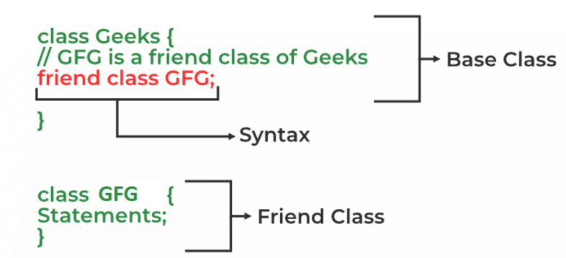
Code walkthrough:
class MyClass {
private:
int x;

public:
MyClass(int x) : x(x) {}

friend class MyFriendClass; // Declare MyFriendClass as a friend
};

class MyFriendClass {
public:
void printMyClassValue(MyClass obj) {
cout << "Value of x in MyClass: " << obj.x << endl; // Access private member of MyClass
}
};

int main() {
MyClass myObject(10);
MyFriendClass myFriend;

myFriend.printMyClassValue(myObject); // Call function from MyFriendClass

return 0;
}
Syntax: friend class classname
Friend function
Like a friend class, a friend function can be granted special access to private and protected members of a class in C++. They are not the member functions of the class but can access and manipulate the private and protected members of that class for they are declared as friends.
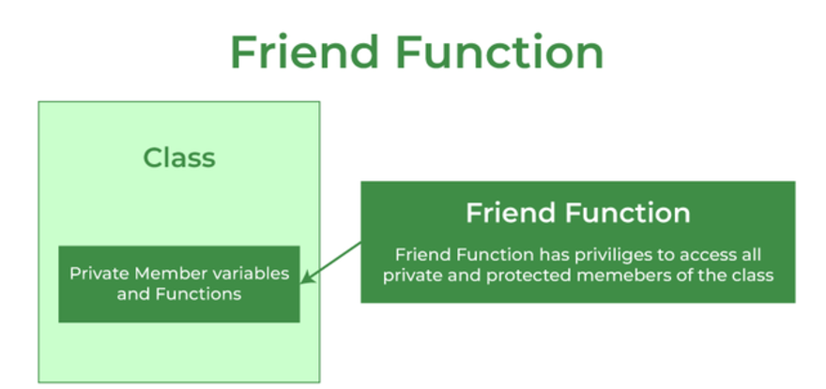

Friend Function Types
A friend function can be:
- A global function: This is the most common type of friend function. It is declared outside any class and can be accessed from anywhere in the program.
- A member function of another class: This type of friend function is declared as a member function of a class that is not the class whose private or protected members it needs to access.
Global function as a friend function:
#include <iostream>
using namespace std;

class base {
private:
int private_variable;

protected:
int protected_variable;

public:
base()
{
private_variable = 10;
protected_variable = 99;
}

// friend function declaration
friend void friendFunction(base& obj);
};

// friend function definition
void friendFunction(base& obj)
{
cout << "Private Variable: " << obj.private_variable
<< endl;
cout << "Protected Variable: " << obj.protected_variable;
}

// driver code
int main()
{
base object1;
friendFunction(object1);

return 0;
}
Member function of another class as friend function:
#include <iostream>
using namespace std;

class base; // forward definition needed
// another class in which function is declared
class anotherClass {
public:
void memberFunction(base& obj);
};

// base class for which friend is declared
class base {
private:
int private_variable;

protected:
int protected_variable;

public:
base()
{
private_variable = 10;
protected_variable = 99;
}

// friend function declaration
friend void anotherClass::memberFunction(base&);
};

// friend function definition
void anotherClass::memberFunction(base& obj)
{
cout << "Private Variable: " << obj.private_variable
<< endl;
cout << "Protected Variable: " << obj.protected_variable;
}

// driver code
int main()
{
base object1;
anotherClass object2;
object2.memberFunction(object1);

return 0;
}
Note:
The order in which we define the friend function of another class is important. We always have to define both the classes before the function definition. This is because the friend function needs to have access to the private and protected members of the class, which are not accessible until the class is fully defined.

Operator Overloading in C++
In C++, operator overloading is a compile-time polymorphism. It is an idea of giving special meaning to an existing operator in C++ without changing its original meaning.
Operator overloading allows you to define the meaning of operators for user-defined data types, such as classes and structures. This enables you to use the same operators with your custom types as you would with built-in types, like integers and strings.
In this example, we have 3 variables “a1”, “a2” and “a3” of type “class A”. Here we are trying to add two objects “a1” and “a2”, which are of user-defined type i.e. of type “class A” using the “+” operator. This is not allowed, because the addition operator “+” is predefined to operate only on built-in data types. But here, “class A” is a user-defined type, so the compiler generates an error. This is where the concept of “Operator overloading” comes in.
Now, if the user wants to make the operator “+” add two class objects, the user has to redefine the meaning of the “+” operator such that it adds two class objects. This is done by using the concept of “Operator overloading”. So the main idea behind “Operator overloading” is to use C++ operators with class variables or class objects. Redefining the meaning of operators really does not change their original meaning; instead, they have been given additional meaning along with their existing ones.
class ComplexNumber {
private:
double real;
double imaginary;

public:
ComplexNumber(double real, double imaginary) : real(real), imaginary(imaginary) {}

ComplexNumber operator+(const ComplexNumber& other) {
return ComplexNumber(real + other.real, imaginary + other.imaginary);
}
};

int main() {
ComplexNumber c1(2, 3);
ComplexNumber c2(4, 5);

ComplexNumber c3 = c1 + c2; // Use overloaded + operator

return 0;
}
Overloaded Operators
You can overload most of the built-in operators, including:
- Arithmetic operators (+, -, *, /, %)
- Comparison operators (==, !=, <, >, <=, >=)
- Logical operators (&&, ||, !)
- Assignment operators (=, +=, -=, *=, /=, %=, &=, |=, ^=, <<=, >>=)
- Increment/decrement operators (++ --)
- Subscript operator ([])
- Function call operator ()
Notes
- You cannot overload the following operators:
  - :: (scope resolution operator)
  - . (member access operator)
  - .* (pointer-to-member access operator)
  - ?: (conditional operator)
  - , (comma operator)
Sample syntax for overloading operators:
class ComplexNumber {
private:
double real;
double imaginary;

public:
ComplexNumber(double real, double imaginary) : real(real), imaginary(imaginary) {}

// Arithmetic operators
For +
ComplexNumber operator+(const ComplexNumber& other) {
return ComplexNumber(real + other.real, imaginary + other.imaginary);
}
For -

ComplexNumber operator-(const ComplexNumber& other) {
return ComplexNumber(real - other.real, imaginary - other.imaginary);
}
For *
ComplexNumber operator*(const ComplexNumber& other) {
return ComplexNumber(real * other.real - imaginary * other.imaginary,
real * other.imaginary + imaginary * other.real);
}
For /
ComplexNumber operator/(const ComplexNumber& other) {
double denominator = other.real * other.real + other.imaginary * other.imaginary;
return ComplexNumber((real * other.real + imaginary * other.imaginary) / denominator,
(imaginary * other.real - real * other.imaginary) / denominator);
}
For ==
// Comparison operators
bool operator==(const ComplexNumber& other) {
return real == other.real && imaginary == other.imaginary;
}
For !=
bool operator!=(const ComplexNumber& other) {
return !(*this == other);
}
};
Operator Overloading with Built-in Data Types
class ComplexNumber {
private:
double real;
double imaginary;

public:
ComplexNumber(double real, double imaginary) : real(real), imaginary(imaginary) {}

// Arithmetic operators with integers
ComplexNumber operator+(int value) {
return ComplexNumber(real + value, imaginary);
}
ComplexNumber operator-(int value) {
return ComplexNumber(real - value, imaginary);
}
ComplexNumber operator*(int value) {
return ComplexNumber(real * value, imaginary * value);
}
ComplexNumber operator/(int value) {
return ComplexNumber(real / value, imaginary / value);
}

// Comparison operators with integers
bool operator==(int value) {
return real == value;
}
bool operator!=(int value) {
return !(*this == value);
}
};
Multiple choice questions for better understanding
